**How Viruses Work**

by [Craig Freudenrich, Ph.D.](http://science.howstuffworks.com/life/cellular-microscopic/virus-human2.htm/about-author.htm#freudenrich)

Browse the article [**How Viruses Work**](http://science.howstuffworks.com/life/cellular-microscopic/virus-human.htm)

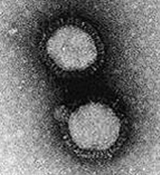

**The flu virus**

Photo courtesy CDC

**Introduction to How Viruses Work**

Most of us at one time or another have had colds or the flu, and we are especially vulnerable during the cold and flu season. The symptoms -- fever, congestion, coughing, sore throat -- spread through offices, schools and homes, no matter where in the world we live. Colds and flu (influenza) are caused by **viruses**. Viruses are responsible for many other serious, often deadly, diseases including [acquired immunodeficiency syndrome](http://science.howstuffworks.com/life/aids.htm) (**AIDS**), **Ebola** hemorrhagic fever, infectious **hepatitis** and**herpes**. How can viruses cause so much trouble? What makes us so vulnerable to them, and what makes them spread?

In this article, we will explore the world of viruses. We'll talk about what a virus is, what viruses look like, how they infect us and how we can reduce the risk of infection. And you'll learn why you feel so miserable when a cold virus attacks your body!

**What Is a Virus?**

If you have read [How Cells Work](http://science.howstuffworks.com/life/cellular-microscopic/cell.htm), you know how both bacteria cells and the cells in your body work. A cell is a stand-alone living entity able to eat, grow and reproduce. Viruses are nothing like that. If you could look at a virus, you would see that a virus is a tiny particle. Virus particles are about one-millionth of an inch (17 to 300 nanometers) long. Viruses are about a thousand times smaller than [bacteria](http://science.howstuffworks.com/life/cellular-microscopic/cell.htm), and bacteria are much smaller than most human cells. Viruses are so small that most cannot be seen with a [light microscope](http://science.howstuffworks.com/light-microscope.htm), but must be observed with an electron microscope.

A virus particle, or **virion**, consists of the following:

* **Nucleic acid** - set of genetic instructions, either [DNA or RNA](http://science.howstuffworks.com/life/cellular-microscopic/cell4.htm), either single-stranded or double-stranded (see [How Cells Work](http://science.howstuffworks.com/life/cellular-microscopic/cell.htm) for details on DNA and RNA)
* **Coat of**[**protein**](http://science.howstuffworks.com/life/cellular-microscopic/cell2.htm) - surrounds the DNA or RNA to protect it
* **Lipid**[**membrane**](http://science.howstuffworks.com/life/cellular-microscopic/cell.htm) - surrounds the protein coat (found only in some viruses, including influenza; these types of viruses are called **enveloped** viruses as opposed to**naked** viruses)

Viruses vary widely in their shape and complexity. Some look like round popcorn balls, while others have a complicated shape that looks like a spider or the Apollo lunar lander.

Unlike human cells or bacteria, viruses don't contain the chemical machinery ([enzymes](http://science.howstuffworks.com/life/cellular-microscopic/cell2.htm)) needed to carry out the chemical reactions for life. Instead, viruses carry only one or two enzymes that decode their genetic instructions. So, a virus must have a **host cell** (bacteria, plant or animal) in which to live and make more viruses. Outside of a host cell, viruses cannot function. For this reason, viruses tread the fine line that separates living things from nonliving things. Most scientists agree that viruses are alive because of what happens when they infect a host cell.

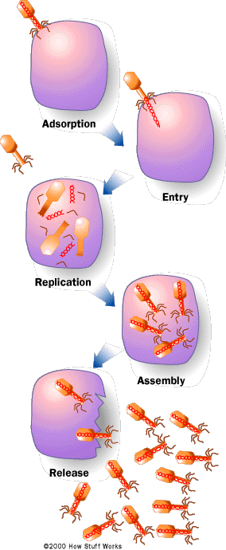

**In the lytic cycle, the virus reproduces itself using the host cell's chemical machinery. The red spiral lines in the drawing indicate the virus's genetic material. The orange portion is the outer shell that protects it.**

©HowStuffWorks

**How a Virus Infects You**

Viruses lie around our environment all of the time just waiting for a host cell to come along. They can enter us through the nose, mouth or breaks in the skin (see [How the Immune System Works](http://health.howstuffworks.com/human-body/systems/immune/immune-system.htm) for details). Once inside, they find a host cell to infect. For example, cold and flu viruses will attack cells that line the [respiratory](http://health.howstuffworks.com/human-body/systems/respiratory/lung.htm) or digestive tracts. The human immunodeficiency virus (HIV), which causes AIDS, attacks the T-cells of the [immune system](http://health.howstuffworks.com/human-body/systems/immune/immune-system.htm).

Regardless of the type of host cell, all viruses follow the same basic steps in what is known as the **lytic cycle**(see figure):

1. A virus particle attaches to a host cell.
2. The particle releases its genetic instructions into the host cell.
3. The injected genetic material recruits the host cell's enzymes.
4. The enzymes make parts for more new virus particles.
5. The new particles assemble the parts into new viruses.
6. The new particles break free from the host cell.

All viruses have some type of protein on the outside coat or envelope that "feels" or "recognizes" the proper host cell(s). This protein attaches the virus to the [membrane](http://science.howstuffworks.com/life/cellular-microscopic/cell.htm) of the host cell. Some enveloped viruses can dissolve right through the cell membrane of the host because both the virus envelope and the cell membrane are made of**lipids**.

Those viruses that do not enter the cell must inject their contents (genetic instructions, enzymes) into the host cell. Those viruses that dissolve into a cell simply release their contents once inside the host. In either case, the results are the same.

**On the Inside**

Once inside the cell, the viral enzymes take over those enzymes of the host cell and begin making copies of the viral genetic instructions and new viral [proteins](http://science.howstuffworks.com/life/cellular-microscopic/cell2.htm) using the virus's genetic instructions and the cell's enzyme machinery (see [How Cells Work](http://science.howstuffworks.com/life/cellular-microscopic/cell.htm) for details on the machinery). The new copies of the viral genetic instructions are packaged inside the new protein coats to make new viruses.

Once the new viruses are made, they leave the host cell in one of two ways:

* They **break** the host cell open (lysis) and destroy the host cell.
* They **pinch out** from the cell membrane and break away (budding) with a piece of the cell membrane surrounding them. This is how enveloped viruses leave the cell. In this way, the host cell is not destroyed.

Once free from the host cell, the new viruses can attack other cells. Because one virus can reproduce thousands of new viruses, viral infections can spread quickly throughout the body.

The sequence of events that occurs when you come down with the flu or a cold is a good demonstration of how a virus works:

1. An infected person sneezes near you.
2. You inhale the virus particle, and it attaches to cells lining the sinuses in your nose.
3. The virus attacks the cells lining the sinuses and rapidly reproduces new viruses.
4. The host cells break, and new viruses spread into your [bloodstream](http://health.howstuffworks.com/human-body/systems/circulatory/blood.htm) and also into your [lungs](http://health.howstuffworks.com/human-body/systems/respiratory/lung.htm). Because you have lost cells lining your sinuses, fluid can flow into your nasal passages and give you a runny nose.
5. Viruses in the fluid that drips down your throat attack the cells lining your throat and give you a sore throat.
6. Viruses in your bloodstream can attack [muscle](http://health.howstuffworks.com/human-body/systems/musculoskeletal/muscle.htm) cells and cause you to have muscle aches.

Your immune system responds to the infection, and in the process of fighting, it produces chemicals called **pyrogens** that cause your body temperature to increase. This **fever** actually helps you to fight the infection by slowing down the rate of viral reproduction, because most of your body's chemical reactions have an optimal temperature of 98.6 degrees Fahrenheit (37 degrees Celsius). If your temperature rises slightly above this, the reactions slow down. This [immune response](http://health.howstuffworks.com/human-body/systems/immune/immune-system.htm)continues until the viruses are eliminated from your body. However, if you sneeze, you can spread thousands of new viruses into the environment to await another host.

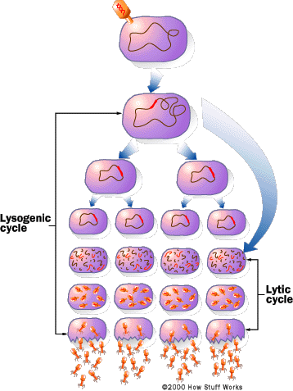

**In the lysogenic cycle, the virus reproduces by first injecting its genetic material, indicated by the red line, into the host cell's genetic instructions.**

©HowStuffWorks

**Lysogenic Cycle**

Once inside the host cell, some viruses, such as herpes and HIV, do not reproduce right away. Instead, they mix their genetic instructions into the host cell's genetic instructions. When the host cell reproduces, the viral genetic instructions get copied into the host cell's offspring.

The host cells may undergo many rounds of reproduction, and then some environmental or predetermined genetic signal will stir the "sleeping" viral instructions. The viral genetic instructions will then take over the host's machinery and make new viruses as described above. This cycle, called the **lysogenic cycle**, is shown in the accompanying figure.

Because a virus is merely a set of genetic instructions surrounded by a protein coat, and because it does not carry out any biochemical reactions of its own, viruses can live for years or longer outside a host cell. Some viruses can "sleep" inside the genetic instructions of the host cells for years before reproducing. For example, a person infected with HIV can live without showing symptoms of AIDS for years, but he or she can still spread the virus to others.

**Reducing the Spread**

As discussed above, viruses can exist for a long time outside the body. The way that viruses spread is specific to the type of virus. They can be spread through the following means:

* **Carrier organisms** - [mosquitoes](http://animals.howstuffworks.com/insects/mosquito.htm), fleas
* **The air**
* **Direct transfer of body fluids** from one person to another -- saliva, sweat, nasal mucus, [blood](http://health.howstuffworks.com/human-body/systems/circulatory/blood.htm), semen, vaginal secretions
* **Surfaces on which body fluids have dried**

To reduce the risk of spreading or contacting viruses, here are things you can do:

* Cover your mouth or nose when you sneeze or cough.
* Wash your hands frequently, especially after going to the bathroom or preparing food.
* Avoid contact with the bodily fluids of others.

These practices are not foolproof, but they can help you reduce the risk of viral infection.

**Medicines That Can Help**

Contrary to popular belief, [antibiotics](http://health.howstuffworks.com/medicine/medication/question88.htm) have no effect on a virus. Most antibiotics interfere with the reproduction of bacteria, hindering their creation of new genetic instructions or new cell walls. Because viruses do not carry out their own biochemical reactions, antibiotics do not affect them.

Immunizations work by pre-infecting the body so it knows how to produce the right antibodies as soon as the virus starts reproducing. Also, because viruses reproduce so quickly and so often, they can often change slightly. Sometimes, mistakes creep into their genetic instructions. These changes might alter the protein coat slightly, so one year's batch of vaccine might not be as effective against the same type of virus next year. This is why new vaccines must be produced constantly to fight viral infections and prevent outbreaks.

You may have heard of outbreaks of [Ebola virus](http://www.who.int/inf-fs/en/fact103.html) or [West Nile virus](http://www.edcp.org/html/west_nile.html) that have left many people dead. Influenza has killed many people in the past (early in the 20th century), and debate rages over when the next major flu epidemic will occur in the United States. Not all viruses are deadly. For example, people get colds all of the time and do not die. However, even these seemingly harmless viruses can be deadly to a person who already has a weakened immune system -- people with [AIDS](http://science.howstuffworks.com/life/aids.htm),[cancer](http://health.howstuffworks.com/diseases-conditions/cancer/facts/cancer.htm) patients taking chemotherapy, elderly people or newborns. We have to take care not to spread viruses to these especially susceptible people.